
IABSE Future of Design London 2018
Young Designer's Competition: Design Brief
Landmark Structure

Brief
The ArcelorMittal Orbit (refer to Figure 1) was a landmark of the London 2012 Queen Elizabeth Olympic Park. Since the games, it’s legacy has continued, with it now being used as an observation tower, the world’s longest and tallest tunnel slide and the UK’s highest freefall abseil.
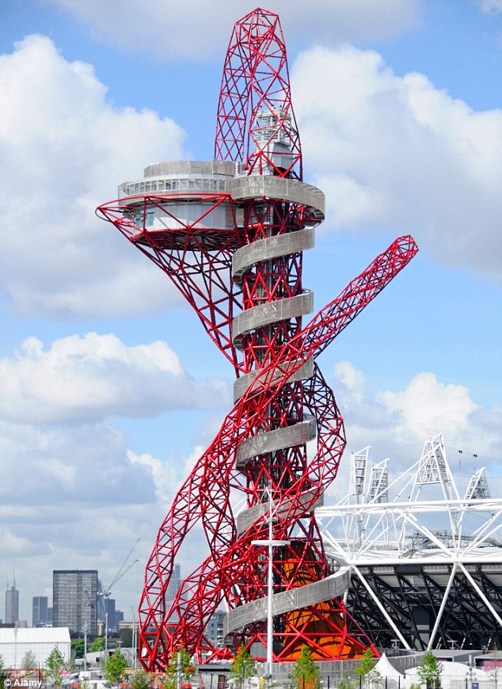
Figure 1 – ArcelorMittal Orbit, Queen Elizabeth Olympic Park
Following the success of this interactive sculpture and its legacy, a new landmark structure is proposed to mark the 2022 Commonwealth Games in Birmingham. Your task is to propose a design for this structure.

Vision for the sculpture
The games organisers have the following vision for the structure:
- It should reflect both the heritage of Birmingham and the Commonwealth Games.
- It should be a permanent structure with relevance and legacy after the games.
- The structure could have a kinematic element, but should not use any external power supply.
- Members of the public should be able to approach and interact with the structure, it should not sit behind any barriers.
Note, this structure could take any form.

Proposal
Designers are expected to propose designs which meet the aspirations in section 2. They may propose a suitable location for the structure within the city. As well as the conceptual design element, designers should demonstrate that they have considered more technical aspects of the design.
The judging criteria will be as follows:
- Structural feasibility
- Innovation
- Adherence to design brief
- Consideration of buildability and ongoing maintenance
- Financial sustainability
The submissions will be judged by a jury of engineers and architects based on these criteria.
It should be noted that the judging criteria focus on the solution to the brief, rather than the mode of presentation. While the quality of the presentation may affect the judges’ decision, it is not essential to produce computer rendered images of the scheme; high quality hand sketches are an adequate communication device.
Depending on the number of submissions received, the jury may decide to shortlist three (or more) schemes to be presented at the conference.
Prizes will be awarded at the jury’s discretion.

Submission details

Format
Submissions are to consist of a single A2 size board, submitted in pdf format by email to events@iabse.org.uk. Boards should include the team’s identification number clearly located in one corner. No other identifying marks (e.g. entrant names, company/organisation names or logos) should be displayed on the boards.
Entries must be submitted before 5pm on 3rd August 2018. Entries received later than this time will be rejected.
Entries should be accompanied by the name of a team member who will be attending the conference. Entries will not be considered for shortlisting if none of the team are available to attend.
The organising committee will arrange for the shortlisted schemes to be printed. These boards will be displayed for public viewing throughout the conference, and will be available for collection at the end of the day.
Teams may consist of up to four team members. All entrants must be under 35 years of age on the date of the conference. A prize of £300 will be awarded to the winning team.

Programme:
18th June 2018 | Design Brief issued
6th July 2018 | End of questions period. Any questions about the brief or the competition should be sent to events@iabse.org.uk. Answers will be made available to all competitors and published on the IABSE UK website.
5pm, 3rd August 2018 | Deadline for competition submission
31st August 2018 | Shortlisted entries notified
19th September 2018 | Judging and Presentation at the IABSE FoD Conference

