Paper Title

 | First Name FAMILY NAME  Title or Position  University or Company  City, Country  E-mail address | Space for a portrait  32 x 48 mm  (If you do not wish to provide a photograph, leave this cell empty) | The curriculum vitae should be a maximum of 40 words (Times New Roman, 10pt).  The title above (Times New Roman, 14pt, Bold, centred, and NOT in Italics) should have a maximum of 60 characters, without any abbreviations. Please use Sentence Case for the Title (i.e. This is the Title of the Paper).
Keywords: The first keyword must be chosen from the following list: Bridges; Buildings; Research; more than one may be used. A list of additional keywords up to a maximum of ten (Times New Roman, 12pt, Italics) may be included, for example: post-tensioning; anchors; slabs; walls; high-rise buildings.

Introduction
This guideline has been prepared in the format that should be used for your one-page paper. Please use this document as a template for your paper. Fonts, sizes and spacing should be used as they are used in this document. Page size is A4, top and bottom margin 15 mm, left and right margin 20 mm.
Body text should be written in Times New Roman, 12 pt, line spacing 12 pt. A new paragraph starts with a half blank line (6 pt) and a new line without indentation.

Content
There must be a minimum of 300 words to describe the subject, purpose and principal content of the paper. The one-page paper may contain images to help draw attention to the subject matter. Any lettering used in figures or tables should be large enough to be readable at a reduced size (10pt): Characters should not be smaller than Times New Roman, 10 pt.
Please do not insert page numbers or headers and footers. Although manuscripts will be reviewed and may in some cases be returned to authors for revision, all initial submissions must be made in the final form, assuming that no revisions will be necessary. Authors are encouraged to use pure English alphabets. Diacritics usage may lead to printing mistakes.
All written material must be in good English. The style, grammar and phrasing should be edited by a person with an excellent command of English and a good understanding of engineering terminology. Papers with poor structure and many grammatical mistakes will be rejected.

Conclusions
The one-page paper must not exceed one page.

References
Any references should be listed using the Harvard style of referencing.
Additional instructions on how to write one-page papers:

Graphics (drawings and photographs) and tables
All graphs, line drawings and photographs should be inserted electronically. The resolution should be 150x150 dpi (dots per inch) for photographs and 300x300 dpi for drawings.
All figures and tables must be inserted near the location where they are first described. Provide a figure number and caption below each figure or photograph and a table number and caption above each table.
Graphics and tables should be aligned with the left or right margin and should not exceed 100 mm in width. Text may be wrapped around graphics and tables, as in this example, if desired. Take care to align text and graphics properly so that they appear tidily on the page.
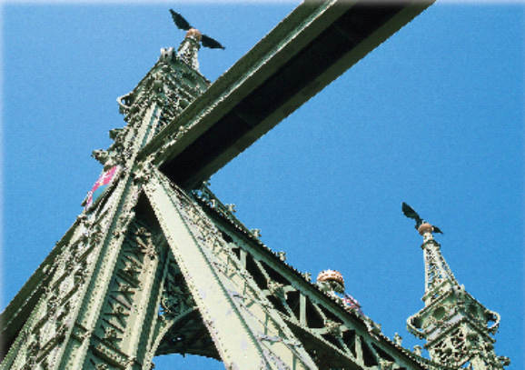
Fig. 1: This is a Figure Caption, 11pt, Italic
When enlarging or reducing images to fit onto the page remember to keep the aspect ratio the same so that images do not end up distorted. This is best done by clicking and dragging the corners of the image and not the sides. In this example, the image and the caption are both contained within a Text Box, so both the box and the image need to be adjusted if the size needs to be increased or reduced.

Tables should have borders for top and bottom and under headings.
Table 1: This is a Table Caption, 11pt, Italic
Yield Line  Number | Normal BM  (Nmm) | Yield Line  Length (mm)
1 | -13,793 | 5,771
2 | -25,058 | 11,660
3 | -18,315 | 11,832
4 | -10,334 | 11,813
5 | -4,335 | 11,638
Use SI units exclusively.

Equations
Insert all equations using the equation editor (integrated in Microsoft Word), as text if possible, or as an image. Equations should be referenced with a number shown in brackets (1), to the right of each equation.
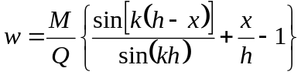 (1)

Submission of Contributions
Your one-page paper shall be submitted electronically as pdf-files by email to events@iabse.org.uk before 5pm of the 2nd of April 2024. Note: the file size must be less than 15MB.
The title, information about the author and the summary with keywords must appear at the beginning of the one-page paper.
The Author's name and the title of the presentation are used as supplied during the submission process i.e. the information filled in online (at link above). It is the author’s responsibility to ensure that Author name and details are the same in the paper and in the data filled online. First and family names should be expanded, middle name can be abbreviated. If you have any queries, contact the organising committee – details on the website.

Copyright
By submitting the one-page paper, authors authorize IABSE to publish the paper in print and electronic form and confirm that they possess all necessary copyrights on text and figures.

